Library Research Sources

The following pages guide you to the various databases in the NU library computer system that will help you find information for a research paper.

The first database is NUcat, which you use to find books.

To get to it, go to the library homepage: http://www.library.northwestern.edu/ . Then click on NUcat in the left menu under “Popular Links.”

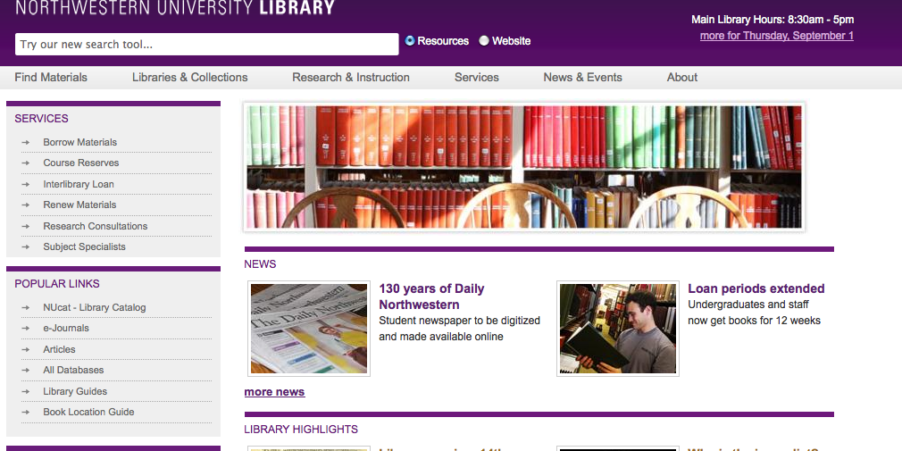

Figure 1: Library homepage with NUcat circled
Library Research Sources—Finding books on NUcat

To locate books on a subject, I usually start with a keyword search. Normally, you need to separate each word in a NUcat keyword search with “and,” but you can also use quotation marks to group words. Figures 2 and 3 show two keyword searches, one that uses quotation marks to group words and one that doesn’t.

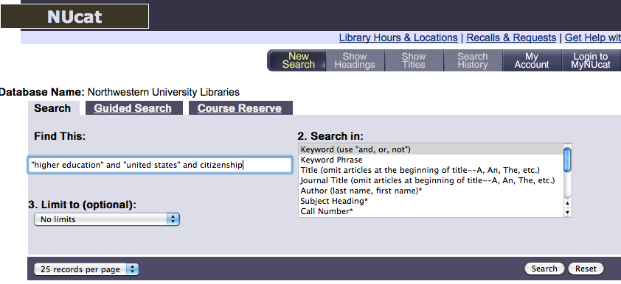

Figure 2: Keyword search with quotation marks to group words

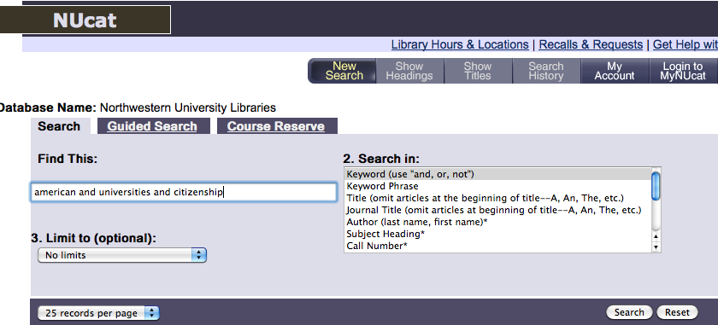

Figure 3: Keyword search without quotation marks to group words
Library Research Sources—Finding books on NUcat

Figure 4 shows a partial screenshot of the results of a keyword search for “higher education” and “united states” and citizenship. Note that you can see not only the title of each book, but its location, call number, copyright date, and status (whether it’s checked out).

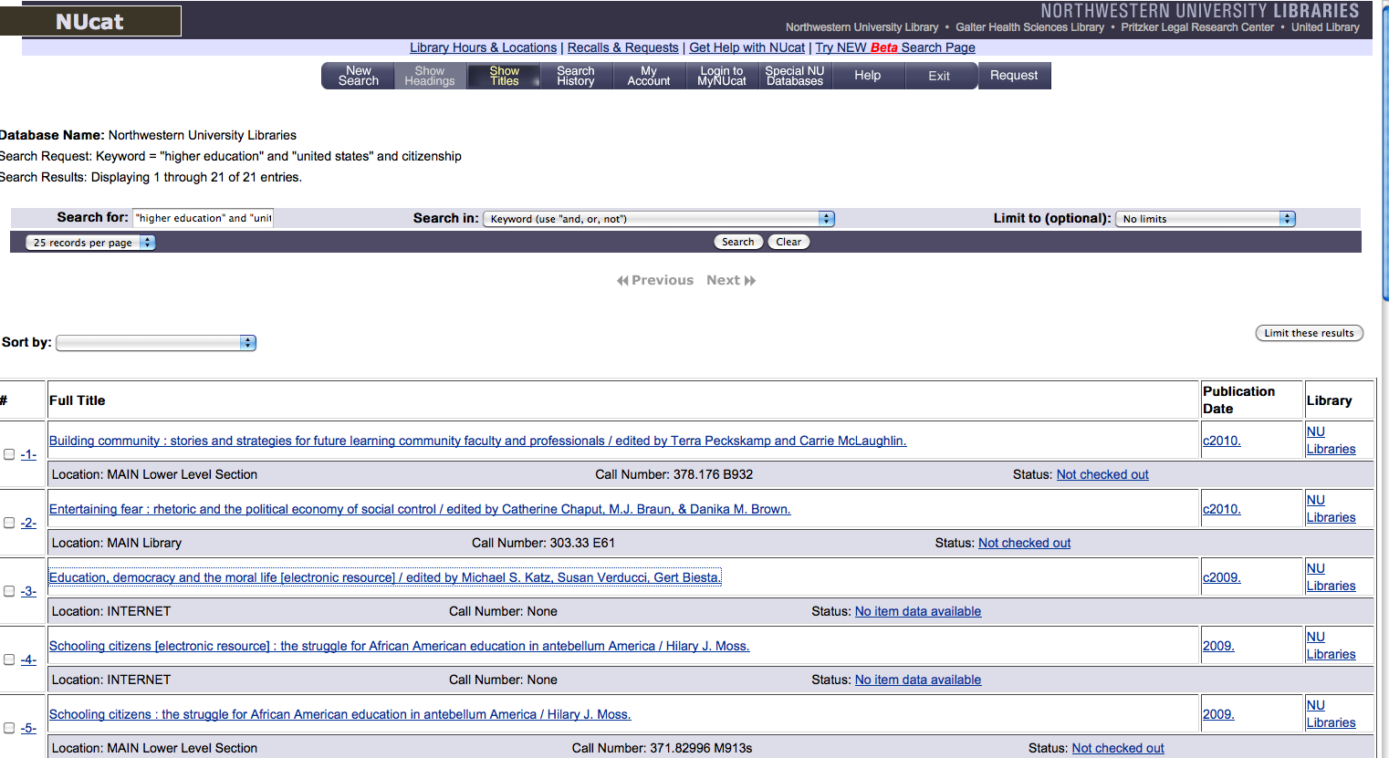

Figure 4: Results of a keyword search (partial screenshot)
Library Research Sources—Finding books on NUcat

Click on the title of the book you’re interested in to see the full record. Note the following:
- Often, especially for more recent books, the record shows the book’s table of contents, helping you decide whether this will be a useful source.
- To find additional search paths, click on the Library of Congress subject links in the record.
- You can email NUCAT records to yourself by filling in the information at the bottom of the search record.
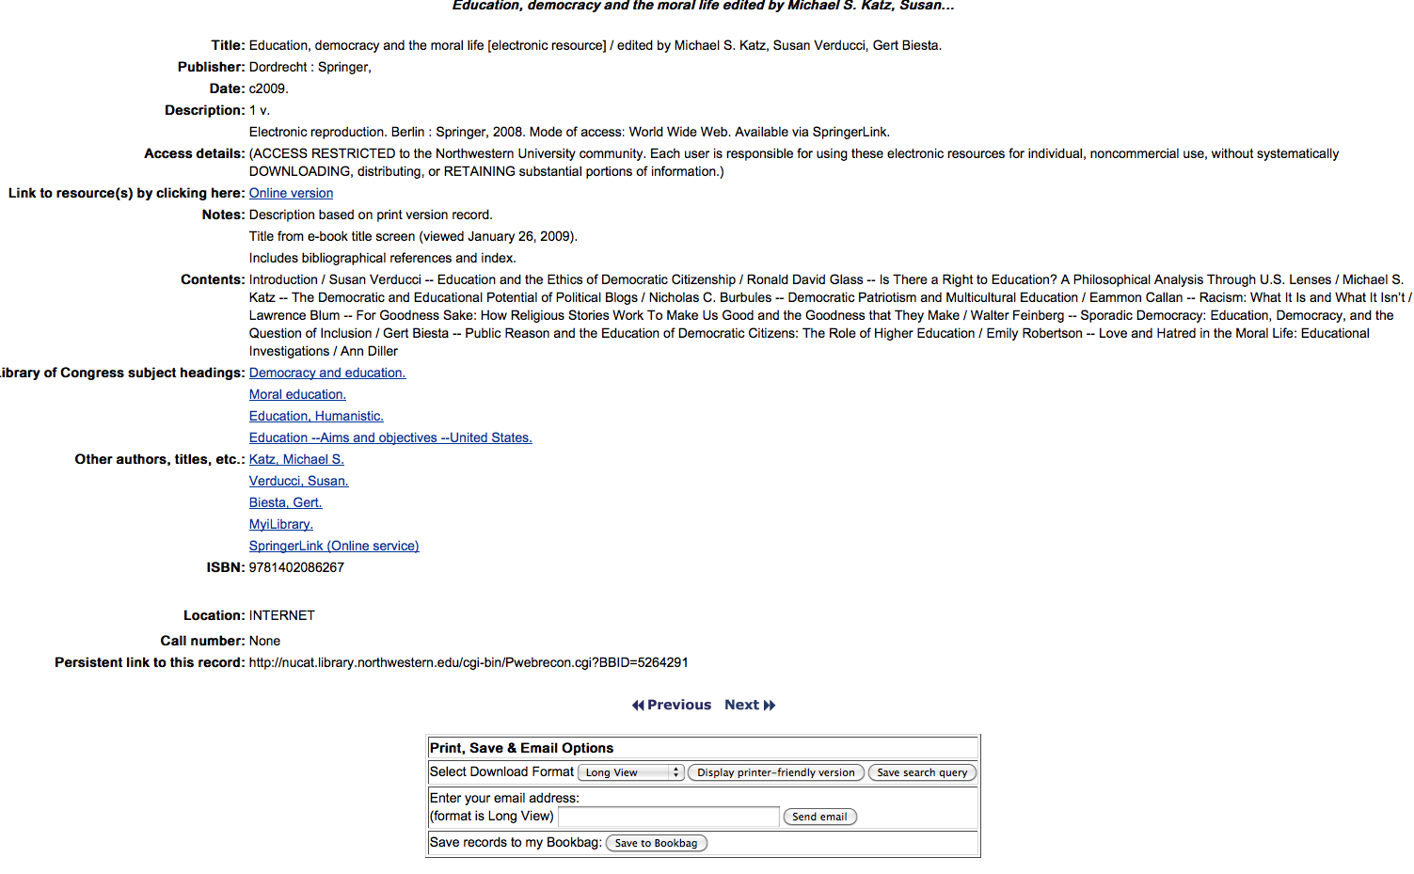

Figure 5: Full record of a selected book
Library Research Sources—Finding articles in Electronic Databases

To find journal, magazine, and newspaper articles, start by returning to the library homepage and clicking on All Databases in the left menu under “Popular Links.”

Figure 6: Library homepage with All Databases circled
Library Research Sources—EXAC

EXAC is an excellent database for finding magazine (i.e., popular) and journal (i.e., specialized and scholarly) articles. To get to it, click on “All Databases” on the homepage, type “exac” into the textbox on the “Find Database” page, and then click “GO.”

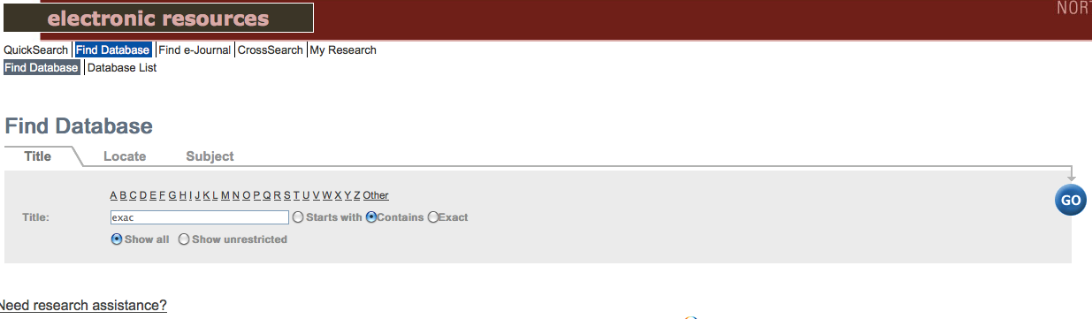

Figure 7: “Find Database” page with “exac” typed in

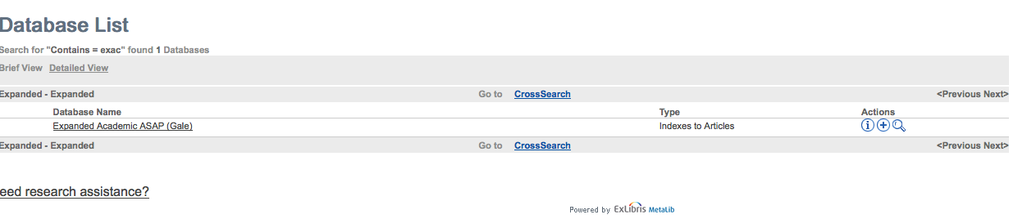

Figure 8: “Database List” page with the full name of “exac” spelled out (Expanded Academic ASAP)
Library Research Sources—EXAC

Click on the database title to get into EXAC. Type search terms into the textboxes. You may need to type many different terms until you get useful articles.

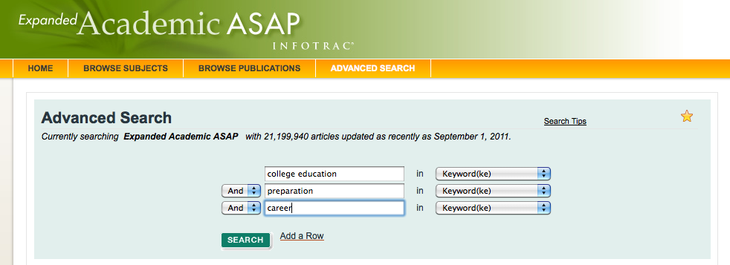

Figure 9: Search terms entered in EXAC

Below is a partial screenshot of the results of the search. Note that only two items have full text.

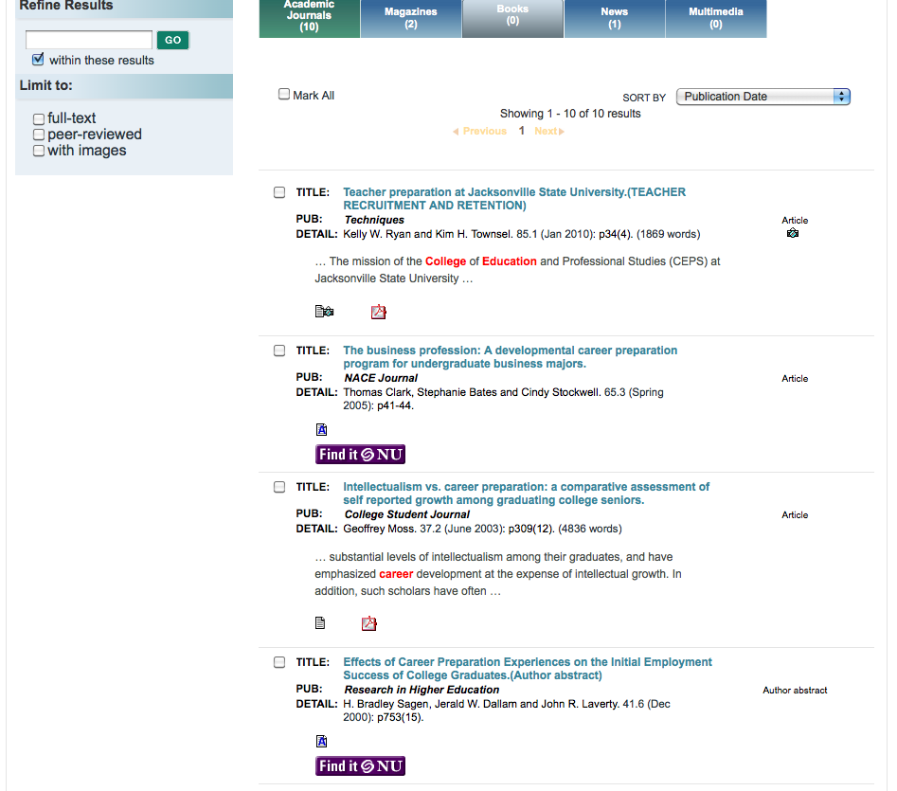
Figure 10: Results of the search (with full text icons circled)
Library Research Sources—EXAC

When the full-text icons are not present, you may still be able to get full text by clicking on the Find It @ NU icon. If full text is available, just click on one of the links that pop up.

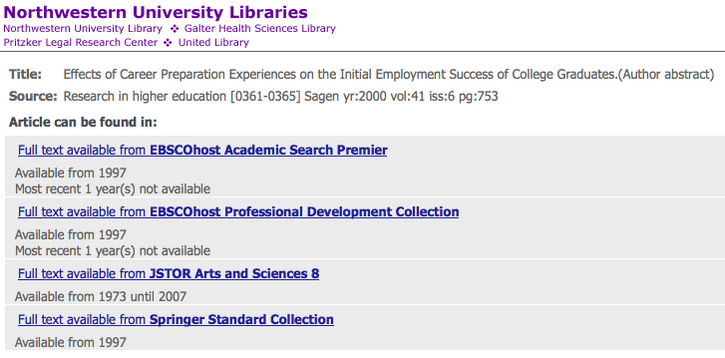

Figure 11: Result of clicking on the “Find It @ NU” icon

Note that you can email articles to yourself.

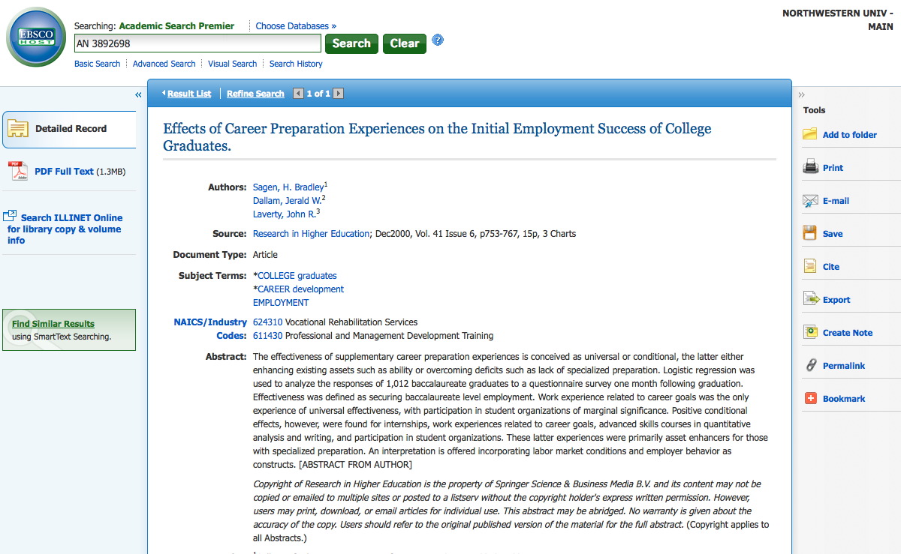

Figure 12: Screenshot with “full text” and “email” links circled
Library Research Sources—LexisNexis Academic

LexisNexis Academic is an excellent database for finding newspaper articles. It contains the full text of all articles. Use it when you are looking for very specific and/or current information. To get to it, click on “All Databases” on the homepage, type “lexisnexis academic” into the textbox on the “Find Database” page, and then click “GO.”

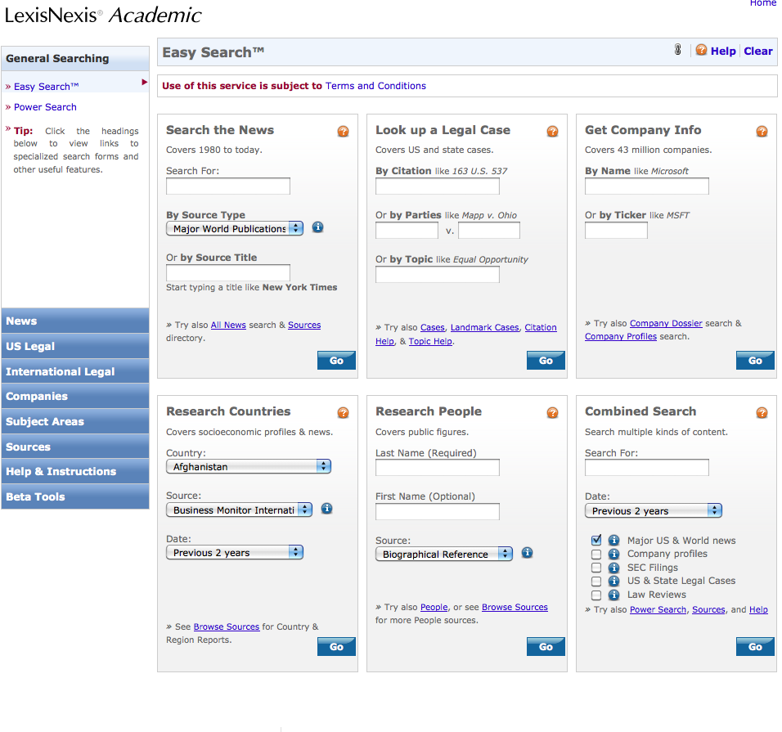
Figure 13: LexisNexis Academic homepage
Library Research Sources—LexisNexis Academic

Figure 14 shows a partial screenshot of a search for “international students and u.s. universities.” Note that I’ve limited the source to The New York Times because that’s a highly credible publication.
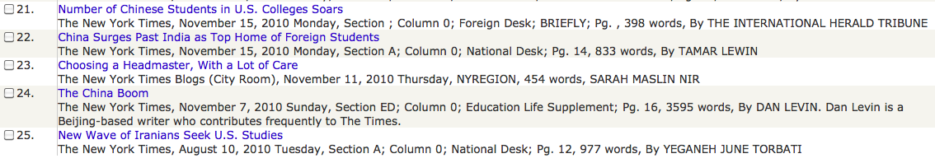
Figure 14: LexisNexis search results (with the search parameters set to The New York Times)

To view the complete article, just click on the title. You can email all articles to yourself.

